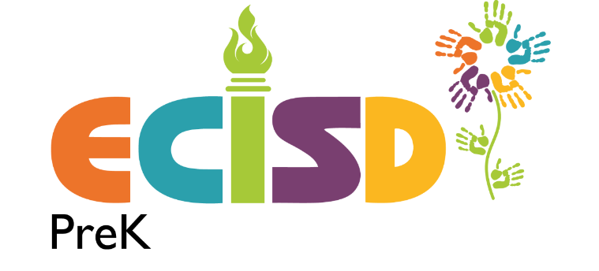

Prekindergarten Family Engagement Plan
ECISD has developed and will implement this prekindergarten family engagement plan to assist the district in achieving and maintaining high levels of family engagement in prekindergarten and positive attitudes toward education at the prekindergarten level. This family engagement plan is developed is designed to support the six components and supporting family engagement activities are outlined below.
Facilitate family- to- family support
ECISD Partners in Education
ECISD partner’s in education department coordinates a variety of activities to bring parents and community members together in support of ECISD students and teachers. Partners in Education connects families, teachers and students through mentoring programs, volunteer opportunities and community outreach efforts.
Establish a Network of Community Resources
Support services for Homeless Students
The McKinney- Vento Homeless Education Act is a federal law that ensures immediate enrollment and education stability for homeless children and youth. ECISD also provides supplemental educational services to homeless students in need and connects families with community- based resources as well.
Special Education and Child Find
Child Find is a process designed to locate, identify, and evaluate children with disabilities who are in need of Early Childhood Intervention (ECI) Programs or Special Education and Related Services. Child Find is available to all children in the community from birth to age 21.
Increase Family Participation in Decision Making
Campus Improvement Teams
Each campus has a Campus Improvement Team (CIT) compromised of administrators, teachers, parents and community members. The team provides input on the Campus Improvement Plan (CIP) and the campus goals and strategies used to improve student achievement. Members are selected by the school administration at the beginning of each school year. Contact the campus for more information.
Parent Portal
The parent portal provides online access where parents and guardians can view helpful student information to support and guide their children through the education process. The parent portal gives ECISD parents or guardians the access to their students’ homeroom teacher, schedule, absences, grades and more. Please contact your students’ campus to obtain your username and password.
Equip Families with the Tools to Enhance and Extend Learning
Campus and Family Learning Events
Each prekindergarten campus host family learning events that are open to all families on the campus. These events are designed to expose families to learning resources that may be used in the home. Check your campus’s website for more information.
Develop Staff Skill In Evidence- Based Practices That Support Families in Meeting Their Children’s Learning Benchmark
Teacher Training Opportunities
Teacher’s receive extensive training in best practices for sharing resources from the Children’s Learning Institute with families. Teachers are trained to support parents in interpreting Circle Progress Monitoring data and they assist parents in accessing the Children’s Learning Institute’s online Parent Connection learning activities.
Evaluate Family Engagement Efforts and Use Evaluations
From parent feedback forms at family events to district- wide parent surveys, a variety of methods are used to collect feedback. The Curriculum and Instruction department will use the data and information collected to evaluate of prekindergarten family engagement practices and to help plan for the next year.

